Notes for 3D Printed ETC Chambers
Last modified by Katherine Holzem (laboratory of Igor Efimov, PhD, Washington University in St. Louis) 5.19.14

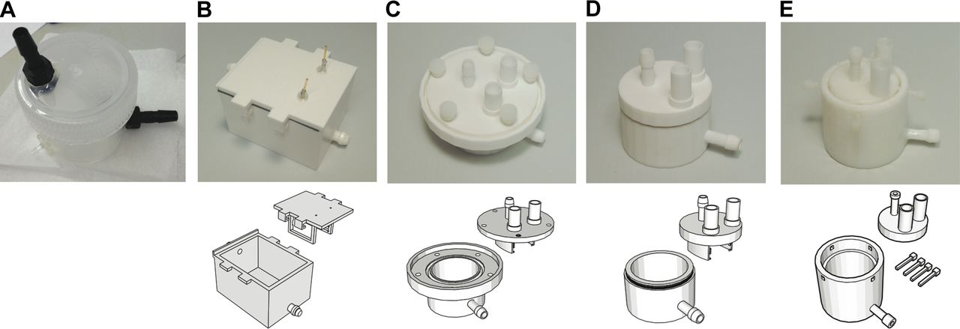

Figure from Sulkin et al. AJP Heart Circ Phys. 2013. STL files for chambers from panel B-E are available, with an additional revision similar to the panel B chamber.

General Notes on 3D printing for ETC.

In general, 3D printing has its limitations for ETC, because of the detergent and high-pressure and temperature system. If printing on a desktop printer, with fused deposition modeling (FDM), ABS plastic is much more suitable than PLA, due to the temperature resistance of the material, and the fact that ABS can be sealed during post-processing using acetone. Even with this processing, it is best to print the ABS with high resolution and infill (as high as possible, or leaking may occur through walls). ABS is also available in a variety of colors, including black, which is ideal for light-sensitive samples. However, depending on the temperature at which you electrophorese your samples, ABS will likely warp during clearing and may not last indefinitely. Polycarbonate, another material now being adopted for desktop printers, unfortunately, does not appear to be suitable for ETC. Though it has optical clarity (good for monitoring samples) and high temperature resistance, it seems to crack in a high-pressure ETC setup. Alternatively, selective laser sintering (SLS), with industrial 3D printers, using nylon material may be better for chambers, but can be costly if parts are ordered through commercial vendors. The other limitation of chambers printed with SLS is that the walls can remain porous, even when several mm thick.

More detailed descriptions for each chamber design, including design limitations, are below.

Panel B.

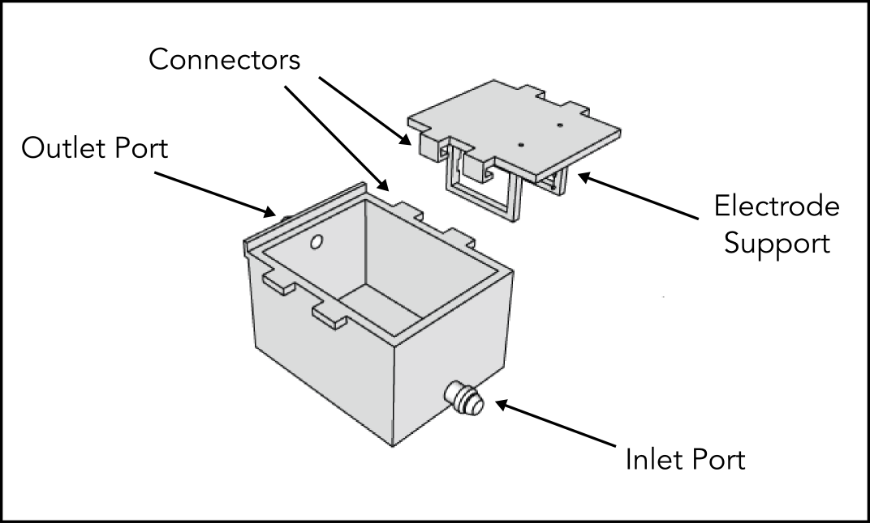
The top and bottom for this chamber interlock well, and the electrode supports include small knobs for electrode attachment. Electrodes come down from the top, so that they can be removed and cleaned easily. As one of our first prototypes, this chamber does not withstand a high pressure, but would be appropriate if using a setup where a peristaltic pump is used for return flow. For the STL file, the inlet and outlet ports may not be patent, which occurred during file repair, but these can be drilled through easily if needed.

Panel C.

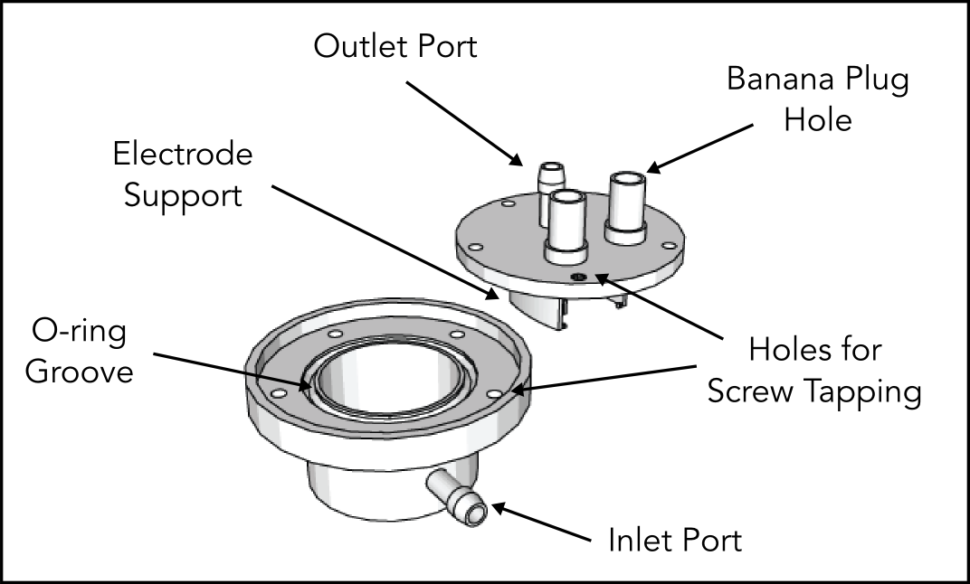

This chamber was designed to improve the pressure that could be tolerated—the design modifications for this purpose include the round design, o-ring groove, and holes which can be tapped for nylon thumb screws—though it still does not seal completely with rapid detergent flow. We attempted many o-rings with various shapes and durometer ratings, and none worked completely. The main successful improvement was the adoption of holes designed to fit banana plug sockets, which were much more stable electrical connections (and easy to do and undo with a banana plug cable). For the STL file, the inlet and outlet ports may not be patent, but these can be drilled through easily.

Panel D.

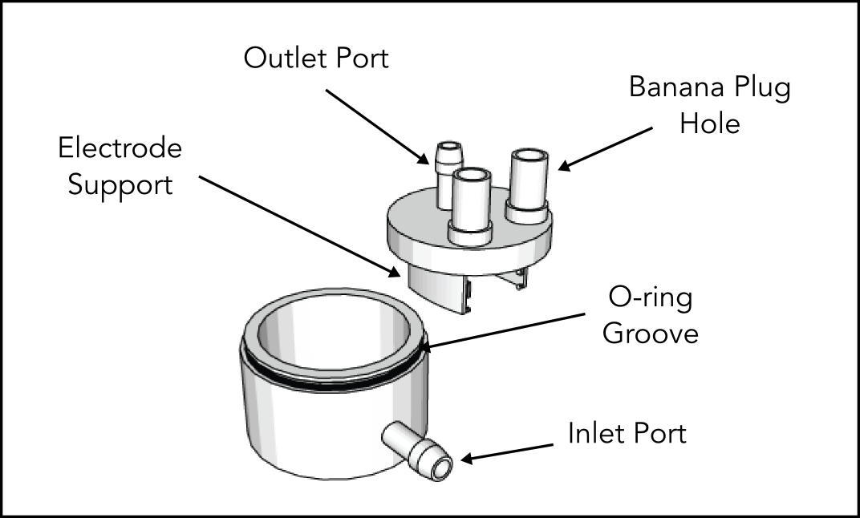

I don’t recommend using the chamber from panel D in its current form. I have included it for completeness, in case anyone would like to improve upon and use this design. There are also several errors in the current STL file, which I have not attempted to repair, because I haven’t pursued this design further.

Panel E.

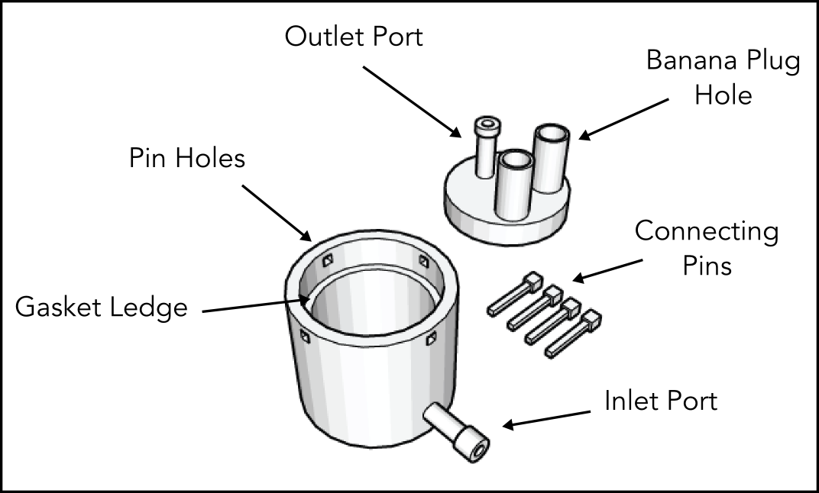
With this chamber, we actually also printed a mold such that we could cast a custom gasket (using Sylgard 184). The design for the mold is also available. Out of all of the chambers, this particular chamber performed the best. The custom gasket helped improve the seal, and the pin connections for the top and bottom made the chamber significantly easier to open and close than previous versions using multiple screws. Printed pins are not particularly strong, and it may just be better to use a small metal rod for this purpose. The STL file for this chamber should be free of errors.

Although we attempted many iterations of 3D printed chambers, we have had better success with our chamber fabricated out of teflon pipe and neoprene pipe end caps. For this design, we utilize 3D printing for internal chamber components. See document on teflon pipe ETC chamber for design.

