Teflon Pipe ETC Chamber Design
Last modified by Katherine Holzem (laboratory of Igor Efimov, PhD, Washington University in St. Louis) 5.19.14

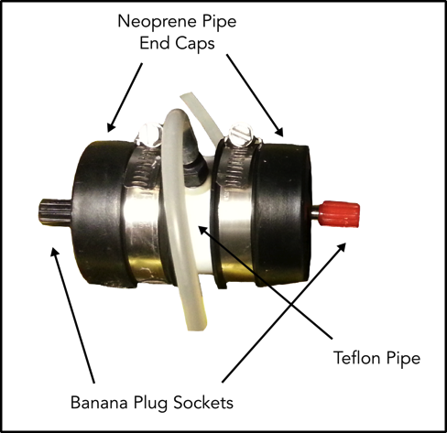

Chamber Supplies:

Teflon Pipe:

Tube Made of Teflon® PTFE, 1-7/8" OD x 1-1/2" ID
McMaster-Carr Cat No. 8547K36
Cut into 3” segments

Pipe-end Caps:

Clamp-Tight Pipe-End Caps
McMaster-Carr Cat No. 2394K11

Banana Plug Sockets (Black and Red):

Post, Binding; Screw; 15 A; 1000 VAC; Brass; Nylon; Black; #6-32;

Post, Binding; Screw; 15 A; 1000 VAC; Brass; Nylon; Red; #6-32;
Allied Electronics Cat No. 70183190 (Black), 70183189 (Red)

Barbed Tube Fittings:

Durable Nylon Tight-Seal Barbed Tube Fitting Straight for 1/4" Tube ID X 1/8 Male Pipe, Black
McMaster-Carr Cat No. 5463K245

Non-conductive mesh:

Stretchable Molded Plastic Mesh Chemical-Resistant Polypropylene 15 x 11
McMaster-Carr Cat No. 9265T51

Platinum or Pt-IR (90-10) wire
3D printed electrode supports (ABS Material)

Chamber Assembly:

Preparation Steps:

1) Cut Teflon pipe to 3” length pieces.
2) Drill holes in pipe for tube fittings (approximately 120° apart, in the middle of the pipe length). Epoxy in tube fittings.

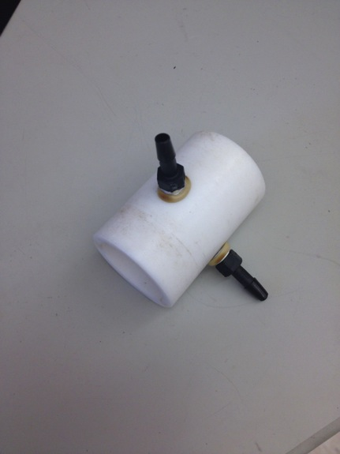

3) Drill depression in metal binding post (on the opposite side from banana socket; makes it easier to solder on wire)
4) Solder wire to binding post
5) Poke holes in the center of each pipe-end cap (can be done with a large IV needle)
6) 3D print electrode support components
I typically have our machine shop help with preparation steps 1-3, and 5. Their tools are much better suited than what we have around the lab.

Assembly Steps:

1) Once the wire is soldered, it can be fed through the hole in the pipe-end cap.

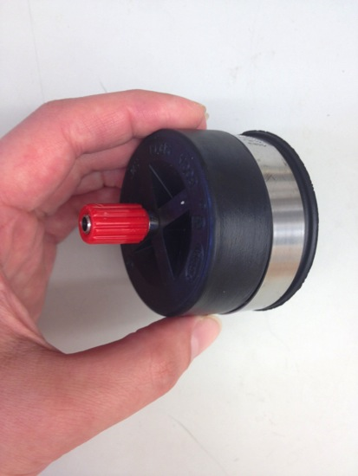

2) Feed the bottom part of the electrode support onto wire, then curl wire around guide posts.

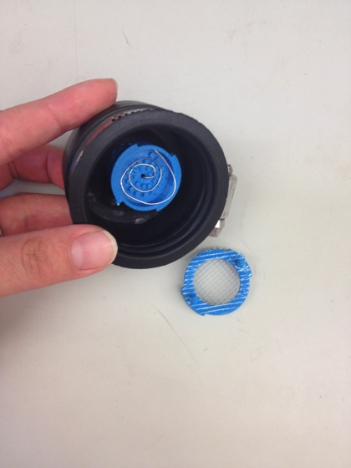

3) Glue non-conductive mesh to top electrode support (as shown above).
4) Attach top electrode support, by fitting top and bottom ridges and turning counterclockwise.

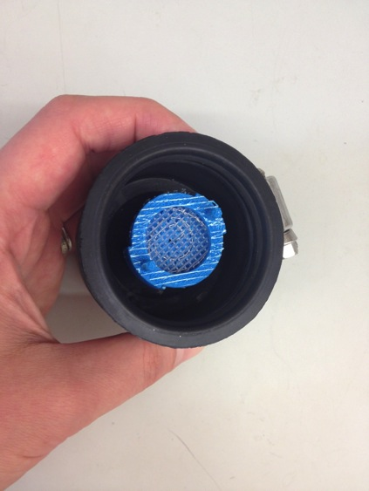

5) Repeat steps 1-4 for other end-cap.
6) Can now put end-caps on teflon pipe, and use screws to tighten down. The pipe should have enough inner tolerance for the electrode support.

